How to run the prototype

# Running runnable prototype:

Requirements:

* Java JDK 21+ or higher
* Windows 10 or higher

1. Open the folder called “Prototype”



1. Open the folder called “CSVCruncher Runnable Prototype”



1. Open the jar file “sponsorrun”



# Running source prototype:

Requirements:

* InteliJ IDEA

1. Open InteliJ IDEA



1. Press on the button “Open”

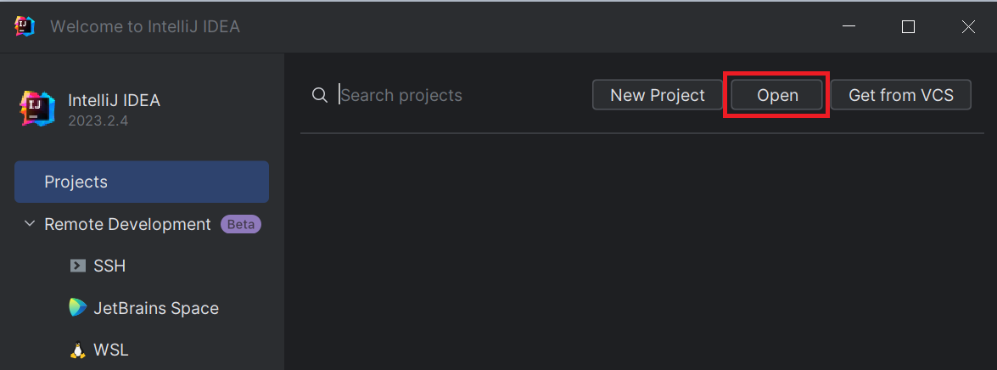

1. Navigate to the folder where the prototypes are downloaded and select “CSVCruncher Source Prototype” inside the “Prototype” folder and press OK



1. Click on Trust Project

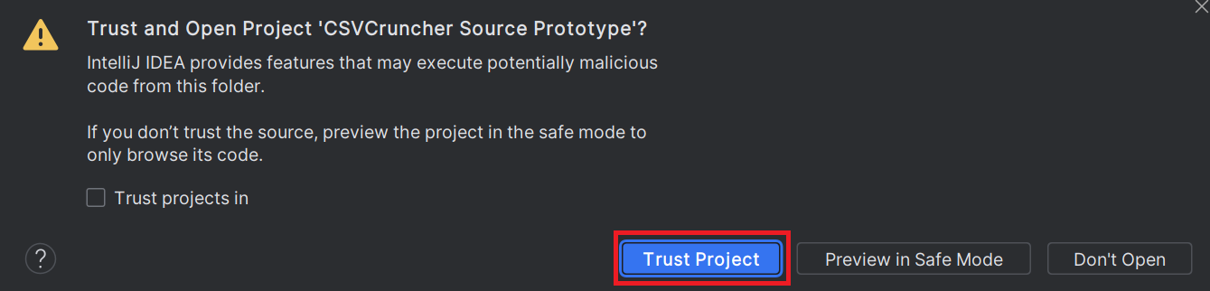

1. Click on the green run button at the top right of the screen

